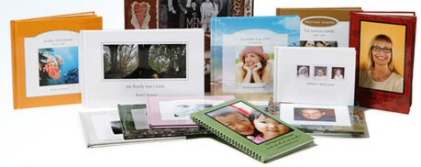

Friends
Hope this finds you all well, I just wanted to tell you about these AMAZING books that I am hosting a celebration for this coming Monday, July 31st. I realize that you can not attend and wanted you to see this new products. You can order from Melinda Steadman and add it to my celebration and she will give you a $20 publisher account FREE, plus it helps me get books at a discount! To be added to my order you have to contact her no later than Monday July 31st. All Melinda’s information is at the bottom.
Heritage Makers is a BRAND NEW company committed to helping build lasting legacies of family heritage! Through the process of Storybooking (combining photographs with personalized story text into a professionally hardbound story book) HERITAGE MAKERS can build bridges between generations by preserving family history stories.
Heritage Makers is a home-based business and online publishing system for creating these stories as well as publishing journals, scrapbooks, creating “scrapless scrapbooks”, cookbooks, calendars and posters!
Heritage Makers also archives the books (at no additional cost!!!), so you never again have to worry about losing your precious journals and pictures to disaster. Multiple copies of your scrapbooks, family history, etc. can be published, so it’s a great way to share grandparent’s histories with the entire family.
How Heritage Makers publishing works:*
You choose what type of book you want to publish.
Upload your pictures to your personal publishing account.
Add the text or story that you want for each page.
Click “Publish” and your book will be delivered to you in 2-3 weeks.
It’s that simple, not to mention cost effective.
*What kind of books can I make?*
*Storybooks – *8x8, 26 to 72 pages
*Brag books – *5x5, 16 to 72 pages
*Designer Books – *12x12 or 8x8 20 to 72 pages
*My Family Tree – *11x7
*Photo Journals – 1*1x8.5 26 to 72 pages
*Scrapless books – *7x5 26 pages
*Posters – *18.5x12.5 and 12.5x18.5
*Family Foldouts – *20x5
*Highlights*
These books are a great way to capture your memories and celebrate your
family’s stories in a way that will be enjoyed for generations to come.
Each book’s pages are full color, high quality, glossy paper and are
hardbound for durability. The books are archived as well, so if you lose
one or it gets destroyed or you just want more copies at a later date,
you can re-order the book without recreating it. Heritage Makers also archives your photos, as many as you want, at no extra charge!
*Not Very Creative – NO PROBLEM!*
At Heritage Makers, when you are creating your book, they give you
online guides and ideas, borders and fonts to work with and give you
ideas to make your books. They even have a project gallery that you can
browse and see what other people have done. For example, you can make
books for weddings, babybooks, life stories, love stories, special
events, military, books about grandparents who have passed on or live
far away, big sister/brother books, family reunion books. They also make
WONDERFUL gifts for any occasion, especially Christmas! The list goes on and
on and it only takes a few clicks of the mouse to complete.
You can also get a discount for ordering multiple books or book packages.

*How do I order?*
After you browse the website, you just call or email Melinda Steadman (the
Consultant) with your order. What you are purchasing is actually book
credits, which gives you a full year to complete whatever book you
ordered.
Please contact Melinda Steadman at rememberingyourroots@satx.rr.com ,if you have any questions. Also, if you’d like to be added to the Heritage Makers email list for monthly specials, please send a request to Melinda at rememberingyourroots@satx.rr.com
Thanks!

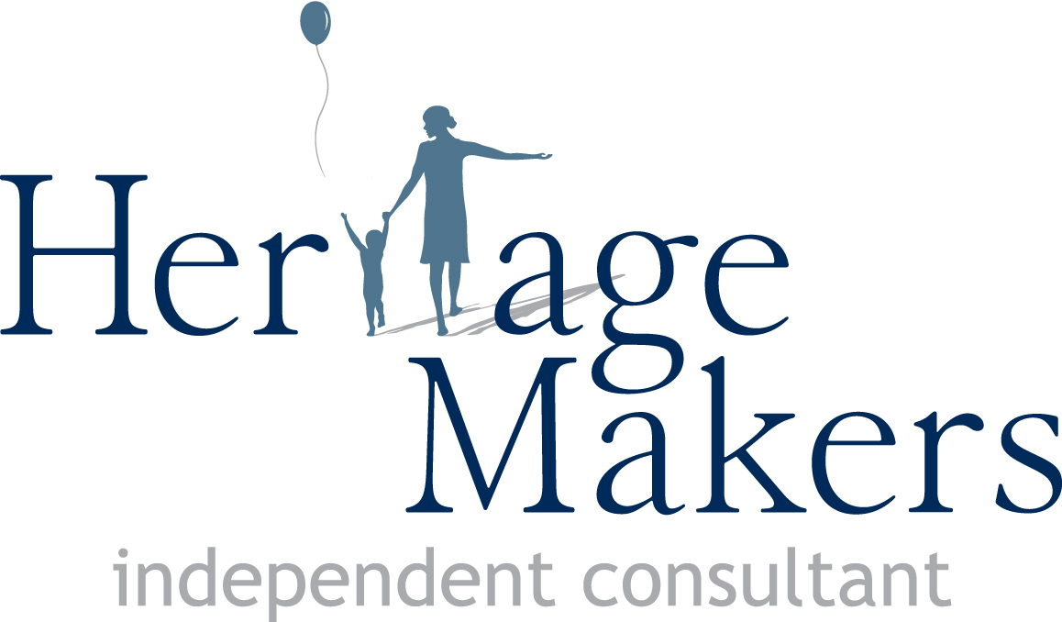

Melinda Steadman
Heritage Makers Founding Consultant
www.rememberingyourroots.com
210-843-1401

